Project B

Jawal Trivedi & Nabeel Azafer

Contents

Executive Summary 3

Individual 3

Jawal Trivedi 3

2D VS 3D Analysis 3

Alternative Boundary Conditions 3

Verification 3

Design Process 4

FEA Concept Analysis 4

Nabeel Azafer 5

2D VS 3D Analysis 5

Alternative Boundary Conditions 5

Verification 6

Design Process 7

FEA Concept Analysis 8

Team 9

Calibration 9

Calibration using 2016 Data 9

Boundary Conditions 10

Material Properties 10

Design Process Team Concept Iterations 10

FEA Analysis 11

Mesh Refinement 11

Convergence Study 12

Verification 13

Predicted Failure of Final Bracket 13

CAM Design 13

Final Design 14

Appendix A – Images 14

# Executive Summary

Project B entailed designing a 2D bracket with a specific stiffness for a light-weight machine. The part was to have a stiffness of 4000 kN/m while displaced downward and 3000 kN/m while displaced upward. Space for a 20mm diameter pipe and four 6mm diameter wires was also to be accounted for during the design. Our team worked to provide a conservative solution, which used more mass, however, according to simulations and calculations will not fail under the loading conditions.

# Individual

## Jawal Trivedi

### 2D VS 3D Analysis

One of the first decisions in the design process was whether to construct a 2D or 3D analysis. Our team individually researched and concluded that a 3D analysis was best. One of the biggest factors in my choice is that I was unable to conduct 2D analysis in the first place. After some brief research, the findings suggest that due to the lack of the 3rd dimension a 2D analysis doesn’t capture the gradient of results in through the third dimension. Due to this, a more *realistic* result is captured in a 3D analysis. The trade-off however is a longer simulation time because of the significantly larger number of nodes in the 3D as compared to the 2D. Due to my previous point, I decided to continue with the 3D analysis.

### Alternative Boundary Conditions

While calibrating, there are two things which can be tweaked: the material properties and the boundary conditions. As the material properties were selected and concrete, it was a tedious back and forth to figure out the correct boundary conditions. A close alternative to the current approach was to keep the pins on A, B and C however apply a Bearing Load on the inner surface of pin D (Refer to Figure 7). The reason we didn’t select this route is because this meant that the deformation was the measurable quantity, not the force reactions. To closely simulate the testing conditions, we opted not to go with the alternative.

### Verification

#### Forces & Displacement

|  |  |
| --- | --- |
| Refer to Figure 15  Conclusion: The Force Reaction value from ANSYS is 2.9KN. Therefore, the error is within ±50%, which suggests it is valid to use the boundary conditions selected on ANSYS. |  |

#### Buckling

|  |  |
| --- | --- |
| Conclusion: In compression the bracket might buckle as its close to the force reaction value, therefore further iterations will need to be carried out to account for this. |  |

### Design Process

|  |  |  |  |  |
| --- | --- | --- | --- | --- |
|  |  | |  |  |
| In the initial design phase I came up with a bunch of designs and analysed them, and none of them were able to achieve the stiffness requirements. | | | | |
| Figure : Bracket Design MK4 | | Figure : Bracket Design MK5 | | |
| In the second phase, I was able to take inspiration from the 2016 model and alter it to the current geometric requirements. (FEA Analysis conducted below) | | | | |
| Figure : Bracket Design MK6 | | | | |
| This was the final concept I decided to take forward despite not meeting the stiffness requirements. (FEA Analysis conducted below) | | | | |

### FEA Concept Analysis

|  |  |  |
| --- | --- | --- |
|  |  |  |
| Bracket Concept MK4 showed a lot of promis, however, the mass was incredibly high. Looking at the Stress Analysis of MK4, I iterated the design to remove the material where there’s less stress.  Force Reaction Down: 4.164 KN  Force Reaction Up: 3.412 KN  Mass: 164.07g | | |
|  |  |  |
| The idea didn’t pan out as I wanted as the stifnees values dipped down again. I reverted back and slimmed down the area between Pin A and D.  Force Reaction Down: 3.170 KN  Force Reaction Up: 2.738 KN  Mass: 135.1g | | |
|  |  |  |
| With the group deadline fast approaching, I took this forward and our team chose MK6 to iterate forwards despite not meeting the stifness requirements.  Force Reaction Down: 3.494 KN  Force Reaction Up: 2.911 KN  Mass: 117.6g | | |

## Nabeel Azafer

### 2D VS 3D Analysis

2D analysis taking far less computational time than 3D meant I was able to quickly generate an analysis to get a rough idea of how well a concept met the specified requirements. I mainly conducted 2D analysis during the very early stages in the design process as I was brainstorming solutions and trying to gain an understanding of what design changes resulted in the most significant impact to the reaction force values. Once I had narrowed down to a few concepts I required more accurate results, so I began using 3D analysis and tetrahedral meshes. This meant my results were more accurate, but at the cost of increased computational time, which is a reasonable trade off considering I had time and wanted to ensure the bracket analysis would accurately model the realistic situation.

### Alternative Boundary Conditions

During the testing stages various boundary conditions were explored which allowed us to understand alternatives whether they increased or decreased the accuracy of the FEA analysis. Initially Instead of adding steel pins to the design, I applied fixed supports at pin holes A, B and C, however upon analysis it was observed that the material around the pin would have zero deformation. This is not accurate because the only part with minimal deformation would be the steel pins itself. Knowing this I added steel pins to the design and applied the fixed support to the pins itself instead of the pin hole. Another possible boundary condition is using a bearing load on pin D instead of a displacement, this will achieve a similar result, but requires a slight change in how modelling and testing of the concepts is conducted. By applying a bearing load up or down (3000N or 4000N), you instead measure displacement and conduct analysis based on achieving a displacement of 1mm. While this is an option, applying a displacement to pin D is the more reasonable and realistic boundary condition because the testing apparatus will be applying a set 1mm displacement up and down.

### Verification

#### Forces & Displacement

|  |  |
| --- | --- |
| Refer to Figure 16  Conclusion: The Force Reaction value from ANSYS is 3.621KN. Therefore, the error is 32% which is within ±50%, this suggests it is valid to use the boundary conditions selected on ANSYS. |  |

#### Buckling

|  |  |
| --- | --- |
| Conclusion: The bracket won’t buckle under the load as force required is well above the predicted load. |  |

### Design Process

|  |  |  |  |  |  |
| --- | --- | --- | --- | --- | --- |
|  |  | |  | |  |
| From this point it was clear bracket 2 was far too weak and dosent generate anything near the required force | | | | | |
|  | |  | |  | |
| While bracket 3 and 4 are overstiff, bracket 1 is understiff and would not generate the required force | | | | | |
|  | | |  | | |
| From this point it is clear the overall design of bracket 3 and 4 is good, but needs some modifications to improve performance. Design 3 has slightly better force reaction values so I chose it as my concept design. | | | | | |
|  | | | | | |

### FEA Concept Analysis

I designed quite a few concepts during the initial stages to test out what factors impacted reaction force results the most. It was clear that adding material as a support to the section along the bottom (Figure 9) did not have a significant impact to most designs and was a waste of material. Adding a column from pin D straight down (Figure 10) was another feature I explored, but in doing so I noticed it didn’t necessarily improve the component’s ability to resist deformation, which can be observed in the FEA below. This was likely due to the stress not being properly distributed, resulting in severe deformation, which was something I avoided for future concepts. From the analysis it was also clear that a support connecting pin A and pin D (Figure 13) was quite an important feature because it provided the right amount of support to make the bracket reach the required stiffness in both directions, doing this however meant space for the wires was limited. To work around the wires, I attempted an arch style strut (Figure 12), but it provided very little support and was considerably weak in comparison to requirements, which is why design 2 was the first to be eliminated. With this information I designed two concepts which embodied some of the features I discussed (Figure 13 and Figure 14) and added a connection from pin D to pin B, these features provided a significantly improved force distribution which can be observed by minimal deformation in the analysis. Furthermore, both designs were considerably stronger than previous concepts whilst still being relatively light. For this reason, I eliminated design 1 because it was under stiff and relatively heavy in comparison to design 3 and 4. While both design 3 and 4 are similar design 3 was 0.016kg lighter and had force values slightly closer to requirements, which is a good indication of a better design and hence why I chose it as my final concept. This design however was still relatively over stiff, which could be improved, and it needed more consideration towards machining.

|  |  |  |
| --- | --- | --- |
| This concept has two internal cut-outs for pipes and cables and is a simple part that is easy to manufacture. The downside is that this concept is under stiff and results in severe deformation even when displaced only 1mm. | | |
|  |  |  |
| Upward Reaction Force: 1430N  Downwards Reaction Force: 1583N  Mass: 0.18698Kg | | |
| This concept uses an arch style support with two internal cut outs, which means there is a large amount of space for the pipe as well as cables. This design however is heavy and under stiff and hence doesn’t generate a large enough reaction force | | |
|  |  |  |
| Up Reaction Force: 1875.3N  Down Reaction Force: 2018.6N  Mass: 0.18868Kg | | |
| This design is light and still has enough space for wires and cables and allows for back-and-forth iteration to improve performance and make it less stiff | | |
|  |  |  |
| Up Reaction Force: 3650.7 N  Down Reaction Force: 4475.2N  Mass: 0.14983kg | | |

# Team

## Calibration

### Calibration using 2016 Data

To be precise with our analysis an example brackets from 2016 was provided, alongside its results during the tensile test. Taking onboard both the CAD model and its data from physical testing, our team started to examine the bracket using numerous loading scenarios. Once the correct Boundary Conditions were found to the testing parameters, we checked for convergence in our results.  After a satisfactory mesh was decided upon, we ensured that the FEA results were within -3% of the actual results, this accounted for discrepancies in our FEA model. Thereafter, we were confidently able to design our bracket using the Boundary Conditions from the calibration.

### Boundary Conditions

For an accurate analysis of the bracket in FEA, our team tested different boundary conditions on the 2016 model, ensuring the results we generated were within 3% of the 2016 sample results. To accommodate for the coefficient of friction between polycarbonate and steel it was necessary for every concept to have steel pins connected to holes A, B, C and D. The design with pins was assembled in inventor and exported to ANSYS. Frictional contacts were applied to each of the four pins with a coefficient of friction value of 0.45. As a range of values was provided for the coefficient of friction, we opted for the median number (0.45) and maintained this number throughout the Project. Fixed supports were applied to each face of the pin (6 faces in total) because it accurately replicated how the fixed supports would be connected to the testing machine. A displacement of 1mm was applied (up or down) to pin D and a force reaction probe was added to the displacement, so that we could analyse force reaction values according to displacement.

### Material Properties

During the Calibration Process, there were a lot of factors within the Boundary Conditions and Material Properties, we could alter to attain the similar data. Our team mainly focused on changing the Boundary Conditions, rather than the material Properties. However, there were two aspects of the material we could adjust; the thickness of the part and the Young’s Modulus. In terms of the thickness the project briefly stated a nominal value of 9.5mm will be used for the bracket, therefore during our initial design phase, we applied the nominal thickness to model our bracket. During the convergence of our design process, we received sample pieces of polycarbonate material from the manufacturer, which was then measured using a micrometre to accurately model our bracket. We received eight samples therefore an average of the thicknesses was used in our model. Calculation X shows the eight values recorded to attain the average of 9.725mm. Another important property was the Young’s Modulus. During our calibration, our team mainly tweaked the boundary conditions to attain figures like the 2016 bracket. However, during the calibration our team didn’t change the value of Young’s Modulus. In hindsight however, perhaps we could have attained matching data quicker had we played around with the Young’s Modulus.

### Design Process Team Concept Iterations

|  |  |  |  |  |
| --- | --- | --- | --- | --- |
|  | |  | |  |
| The black outlines in MK6 (refer to Figure 3) shows the regions that need to be reinforced. | | | | |
|  | |  | |  |
| With the reinforcements applied, the design didn’t improve much. A different avenue was explored in the next iteration. | | | | |
|  | | | | |
| The design didn’t yield the results that we were after, therefore we decided to reinforce the previous design. | | | | |
|  | |  | |  |
| For this iteration we realised the strut at the top could be removed and the oval for the wires could be expanded. We also changed the shape oval alongside reinforcing the pins at the bottom to fit manufacturer’s constraints. This eventually led to our final design. | | | | |
|  |  | |  | |

## FEA Analysis

### Mesh Refinement

For the analysis conducted tetrahedral mesh was conducted globally as well as refinements applied to all the pin holes and internal cut outs. We chose tetrahedral meshing because it was the most accurate even though it took longer to compute. From the analysis it was noted that reducing element size below 8mm for a global refinement didn’t result in significant changes to the reaction force values. We noticed stress discontinuity on pin holes, so we applied refinements there as well as on the internal cut outs to ensure our values converge properly.

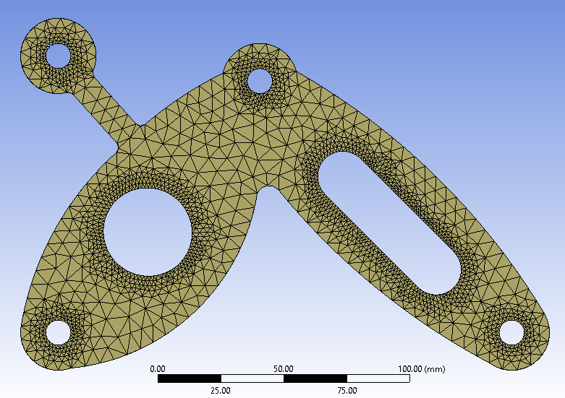

Figure : Locally refined Mesh on Final Design

### Convergence Study

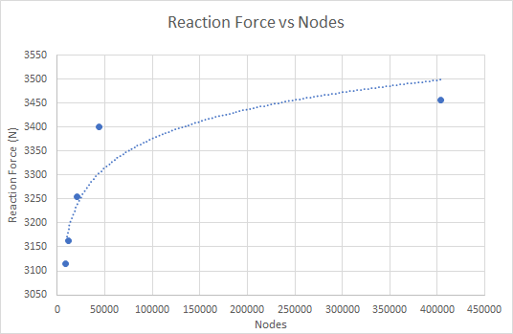

Figure : Mesh Convergence Study

After applying refinements and reducing element sizes globally we can observe in Figure 5 the results converge. This concludes that the values approximately converge at 43000 nodes. This means the validity of results after 43000 is valid.

## Verification

### Predicted Failure of Final Bracket

|  |  |
| --- | --- |
| Conclusion: Our final bracket design will buckle at approximately 13.4KN, which is well above the force reaction predicted by ANSYS. |  |
| Conclusion: The force required to yield is approximately 8.4 KN, which suggests that yielding will occur before buckling. Therefore, the mode of failure is Yielding at 8.4 KN. |  |

## CAM Design

The final concept we opted for has a relatively simple design with only two internal cuts in the part. Knowing this we proceeded to iterate our final concept to improve machining time and minimise complexities during machining. The curve at the bottom (insert reference) needed to have a relatively small curvature for optimal FEA results, knowing this we decided to make the radial curvature 5mm so that we could use the smallest tool (10mm) and have precise machining. It was most effective to maintain one contour around the whole part using the same 10mm diameter tool for both roughing and finishing because it avoids changing tools, hence reducing machining time. The cut out for the wire hole (Insert reference) has a diameter of 20mm and a width of 20mm which are both multiples of the 10mm diameter cutting tool which allowed for a smooth roughing and finishing without having to change to a larger tool size. For the pipe hole we also used the 10mm tool. For this design there was no need to change the tool as it was designed in a way to minimize machining time whilst still maintaining part accuracy.

## Final Design

Figure : Final Design with annotations

# Appendix A – Images

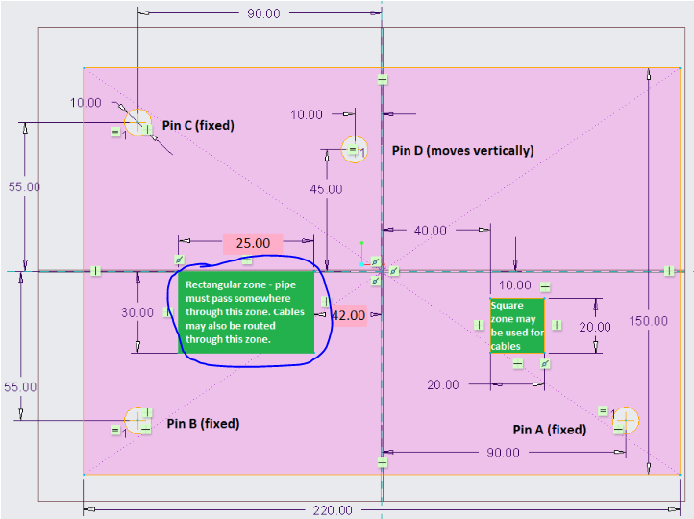

Figure : Geometric Locations of Pins

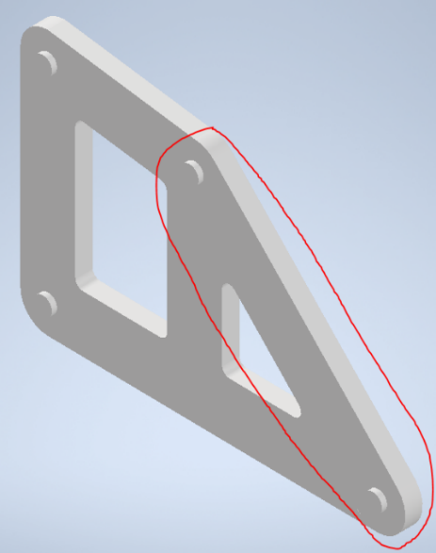

Figure : Concept 1 (A to D Strut)

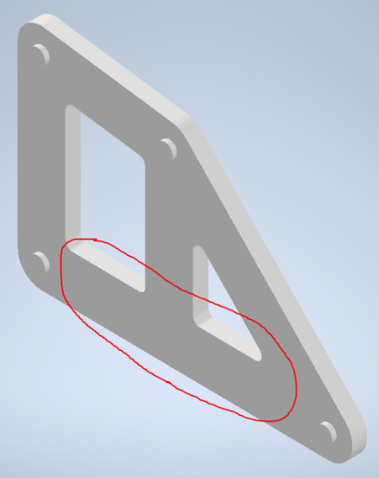

Figure : Concept 1 (A to B Strut)

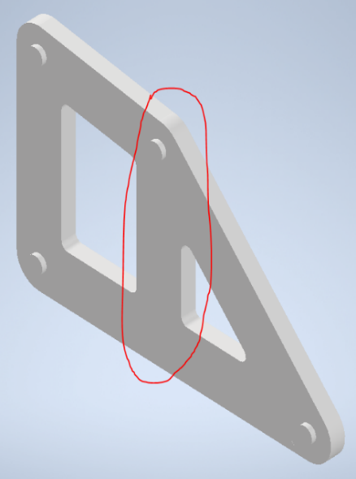

Figure : Concept 1 (Column Support)

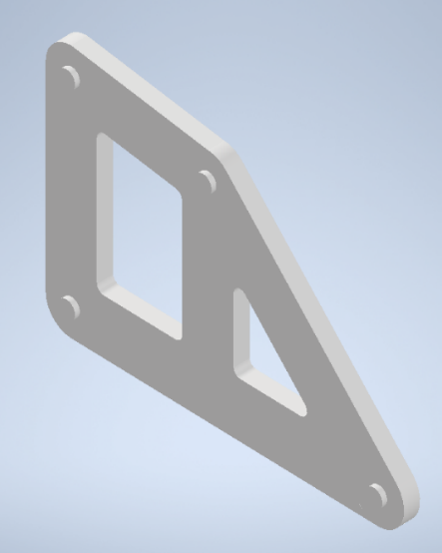

Figure : Concept 1 (NA)

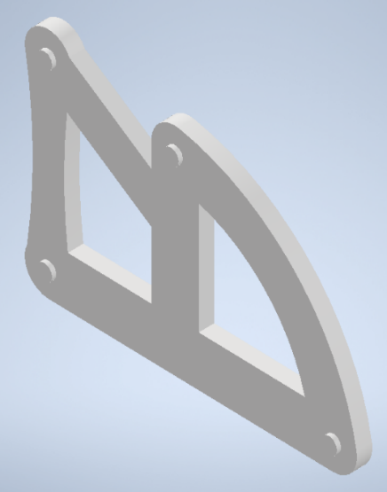

Figure : Concept 2 (NA)

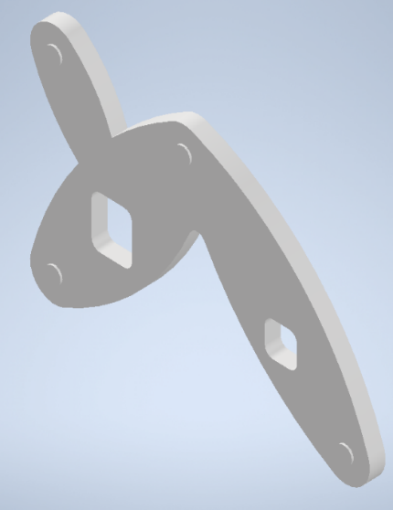

Figure : Concept 3 (NA)

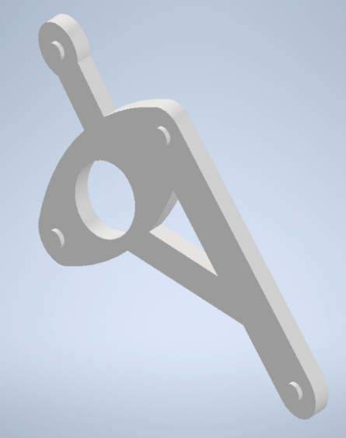

Figure : Concept 4 (NA)

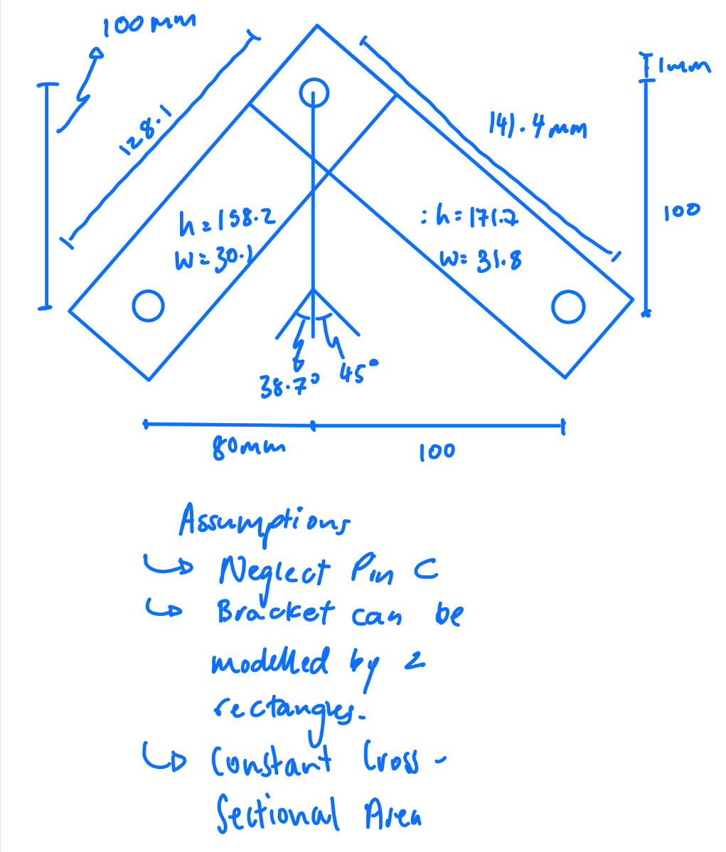

Figure : Force Displacement Calculation Diagram (JT)

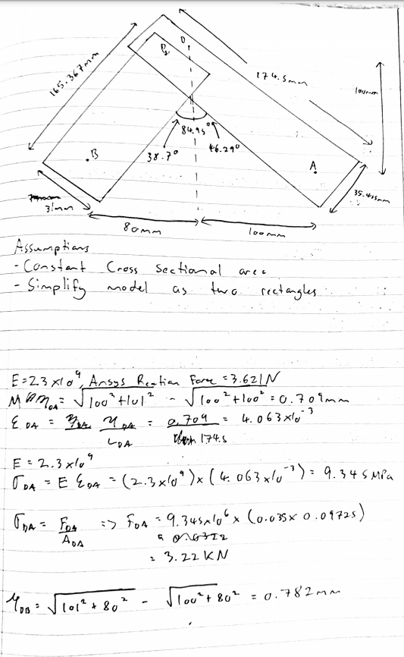

Figure : Force Displacement Calculation Diagram (NA)

**Statement of contributions to team submission**

Please list each element of the work done towards the submission and estimate each team member’s contribution (as a %) to each element. Every team member must sign the completed statement. Include this sheet as the final page of your submission. The first row of the table is an example that should be deleted.

**Course code:** MECHENG 334

**Submission:** 1

**Date: 1st June 2021**

|  |  |  |
| --- | --- | --- |
| **WORK DONE TOWARDS SUBMISSION** | **#1** | **#2** |
| *Manufacturing* | *40* | *60* |
| Concept Design Iterations | 60 | 40 |
| ANSYS | 50 | 50 |
| Report (Team Section) | 50 | 50 |

Team member names (print), and signatures:

#1: Jawal Trivedi

#2: Nabeel Azafer